PROGRAM DESCRIPTION
The Wrightwood Elementary Ski & Snowboard Program is a unique opportunity for our students to learn to ski or snowboard at a discounted price. All students in grades 1st through 5th are invited to participate. This program is offered through MT HIGH RESORT, and is called the Mid Day Snowsports Adventure (MDSA).
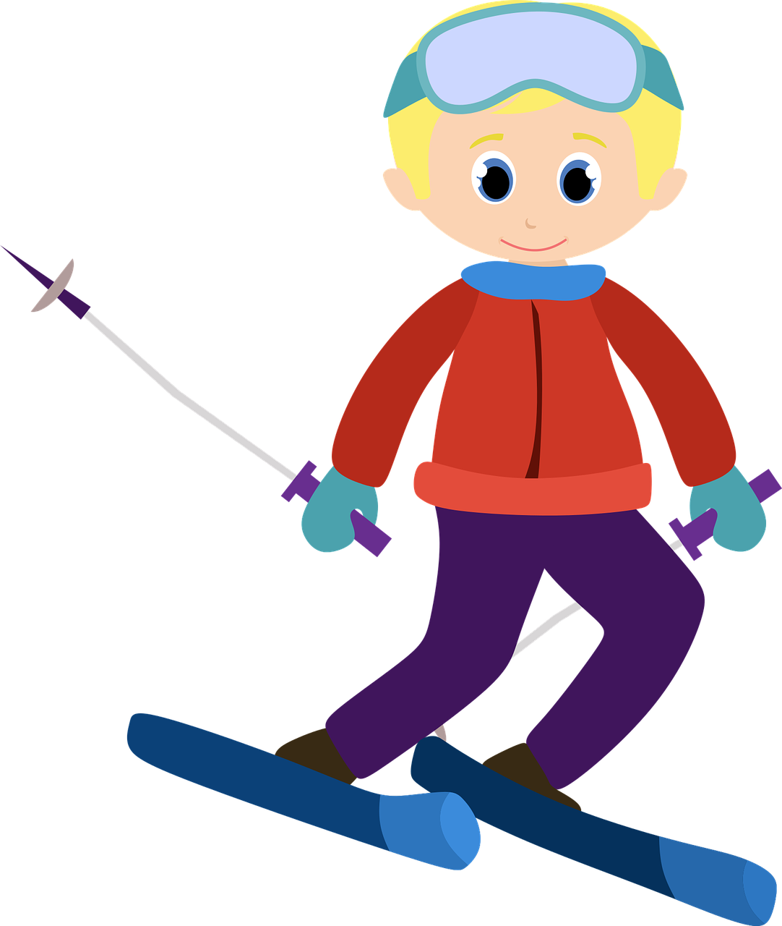

2022 Dates & Time
- The program will run for 4 consecutive Thursdays, weather permitting
- This year’s dates are: January 19th & 26th, February 2nd & 9th
- Lessons start at 3:15pm and last approximately 1 hour & 45 minutes

REGISTRATION STEPS
- Step #1- Please read the 2022-23 Info Packet. Get all your questions answered here!

- Step #2- Complete the online Mt High registration at this link https://shop.mthigh.com/school-groups. You will pay and sign a liability e-form here. See the Mt High flier for additional directions

- Step #3- Complete the Mt High MDSA Ability Level Google form. This form goes directly to program coordinators for class placement

- Step #4- Join our Remind app class to stay updated on program info. Text @wessnow to 81010

Registration must be completed by December 23rd, 2022!

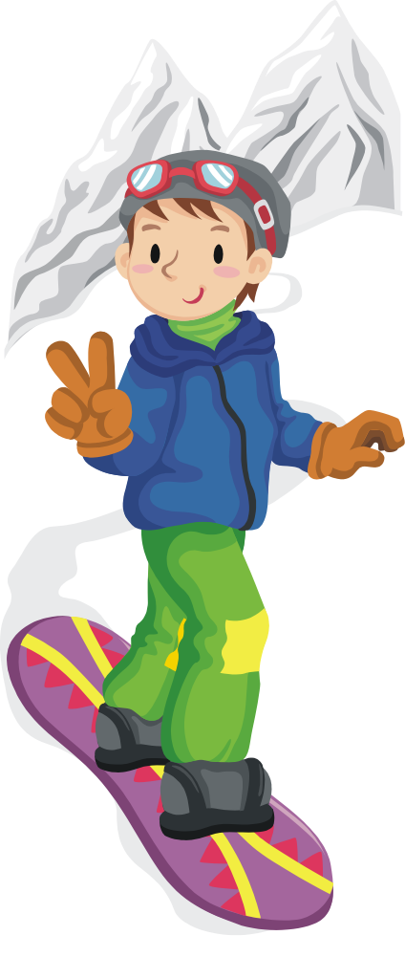
2023 PRICE LIST

MDSA-1 4 lift tickets, 4 lessons & 4 rentals …….……….…….…. $320
MDSA-2 4 lift tickets & 4 lessons (no rentals) ……………........... $260
MDSA-3 4 lessons & 4 rentals (season pass holders ONLY) ...… $200
MDSA-4 4 lessons (season pass holders ONLY, no rentals) ....... $140
Parking all parking areas will charge a fee of $20/day …….…... $40

ARRIVING AT THE MOUNTAIN
- All lessons take place at Mt High West Resort
- Please allow enough time to drive to the resort, park, pick up rentals & walk to the teaching shelf
- Students start the day 1 process at the Group Sales Office located next to the BullWheel restaurant
- Program coordinators will be in the area to assist students

EQUIPMENT RENTALS
- Be prepared to list your student’s weight, height & shoe size
- Snowboarders must specify if they ride regular (left foot in front) or goofy (right foot in front)
- You may choose to rent from Mt High or another vendor
- Allow plenty of time to check out rental equipment and get up to the lesson location on time.

Student DROP OFF/ PICK UP Instructions:
All classes meet at the top teaching shelf by the Bull Wheel restaurant.

DROP OFF: Students will meet instructors at their designated flagpole. Class lists will be hanging from each flagpole

Lessons begin promptly at 3:15pm!

If you are late, have your student wait at their flagpole for the class to return

PICK-UP: Students will return to the flagpole area around 5pm and be dismissed by instructors. Your student must be picked up by an adult

Students are not allowed to go into the Bull Wheel or down to the parking lot alone. They are also not permitted to continue skiing/boarding unsupervised

CLASS ASSIGNMENTS & PASS CARDS
- Class assignments will be posted on the auditorium doors prior to the first lesson
- Students are grouped in classes based on ability and age, as numbers allow
- Your student's class # corresponds to the flagpole # where they will meet each week
- PASS CARDS will be distributed to non-season pass holders on the first lesson day. These cards are activated for our 4 lesson days
- Season pass holders should carry their pass at each lesson
- Please keep pass cards & season passes safe in your students zippered jacket pocket

CLOTHING & SAFETY Equipment
- Helmets are required. Helmets must be designed for snow sports. No bike helmets
- Boots and bindings must fit together and be adjusted. Please have your child’s equipment checked
- Snowboarders: Wrist guards are STRONGLY recommended
- WATERPROOF clothing & WATERPROOF gloves are required
- Goggles or sunglasses are STRONGLY recommended
The temperature drops dramatically once the sun goes below the mountain, so be prepared for COLD.

REMIND:
Please join our Remind app class to stay informed. All program information is sent out via Remind, including any schedule changes due to weather. Text @wessnow to the number 81010

MT HIGH Mid-Day Snowsports Adventure (MDSA) TERMS:
- Replacement of lift passes due to loss or other negligence will result in a $5.00 charge
- LIFT PASSES ARE VALID ON THE SPECIFIED LESSON DATE ONLY
- In order to maintain these low rates, there are NO REFUNDS on or after the first lesson
- There are no make-up lessons for absent students

CHAPERONES
- Each chaperone will receive a complimentary half day lift ticket & rentals (if needed), valid on the day of the lesson
- We cannot guarantee you will be placed with your child
- We ask that chaperones commit to attending all four lesson dates
- Chaperones must be 18 years of age or older
- Volunteer to be a chaperone by completing the Ski/ SB Chaperone Application

QUESTIONS
If you have any questions, please feel free to contact the Ski & Snowboard Program coordinators, via Remind or text (Lyssa at 909-373-5132 and Chris at 714-470-1007). We are here to help!

